**Practical-3**

**Implementation of various sorting methods(bubble and selection) and performing their timing analysis.**

**1. BUBBLE SORT Code:**

#include <stdio.h>

void swap(int *a, int *b)

{ int temp = *a; *a = *b;

*b = temp; }

void Bubble_Sort(int arr[], int n)

{

int i, j;

for(i = 0; i<n; i++) for (j = 0; j<n-i-1; j++) if (arr[j] > arr[j+1]) swap(&arr[j], &arr[j+1]);

}

void Display(int arr[], int size)

{

for(int i=0; i<size; i++) printf("%d ", arr[i]);

}

int main()

{

int n; printf("Enter the number of elements of array: "); scanf("%d",&n);

int arr[n];

for(int i=0; i<n; i++)

{ printf("Enter the %d element: ",i+1); scanf("%d",&arr[i]); }

n = sizeof(arr)/sizeof(arr[0]); Bubble_Sort(arr, n);

printf("\nSorted array: "); Display(arr, n);

return 0;

}

**OUTPUT:**

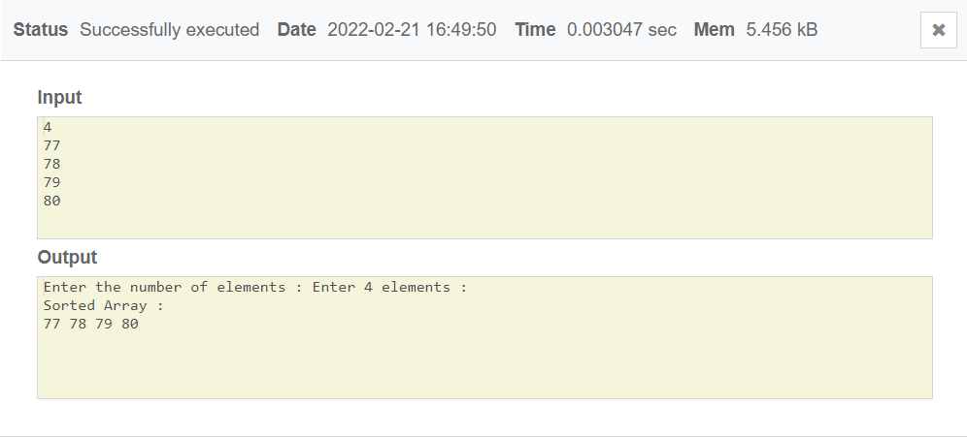

**2. SELECTION SORT Code:**

#include <stdio.h>

void swap(int *a, int *b) { int temp = *a; *a = *b;

*b = temp; }

void Selection_Sort(int arr[], int n)

{

int i, j, min_idx;

for(i = 0; i<n-1; i++)

{ min_idx = i; for(j = i+1; j<n; j++) if (arr[j] < arr[min_idx]) min_idx = j;

swap(&arr[min_idx], &arr[i]);

}

}

void Display(int arr[], int size)

{

int i; for (i=0; i < size; i++) printf("%d ", arr[i]);

}

int main()

{

int n; printf("Enter the number of elemnts of array: "); scanf("%d",&n);

int arr[n];

for(int i=0; i<n; i++)

{ printf("Enter the %d element: ",i+1); scanf("%d",&arr[i]); }

n = sizeof(arr)/sizeof(arr[0]); Selection_Sort(arr, n);

printf("\nSorted array: "); Display(arr, n);

return 0; }

**OUTPUT:**

